Indian Apparel Garments
- 1 Basic half sleeve T-shirt
- 2 Long sleeve Crew neck T-shirts
- 3 Polo collar t-shirt
- 4 V-neck t-shirt
- 5 Wide neck –Off shoulder t-shirts (Girls’)
- 6 Yoke neck t-shirts (Girls’)
- 7 Boyfriend t-shirts (Girls’)
- 8 Douche bag neck t-shirt (Scoop neck)
- 9 Henley collar T-shirt
- 10 Baseball Tshirt
- 11 Raglan sleeve t-shirt – Long sleeve
- 12 Turtle neck shirt
- 13 Ringer T – shirt
- 14 Cap sleeve t-shirt
- 15 Half Tshirt (Singlet)
- 16 Muscle Shirt
- 17 Half Muscle Shirt
- 18 Longline T-shirt
- 19 Pocket T-shirt
- 20 Baby Doll T-shirt

- 1 Basic half sleeve T-shirt

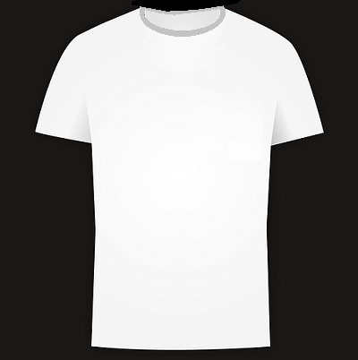
- 2 Long sleeve Crew neck T-shirts

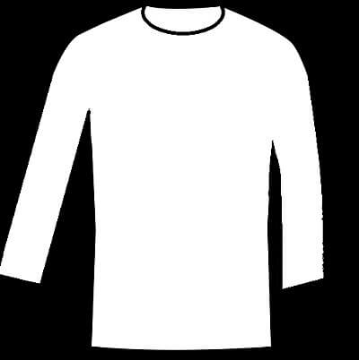
- 3 Polo collar t-shirt

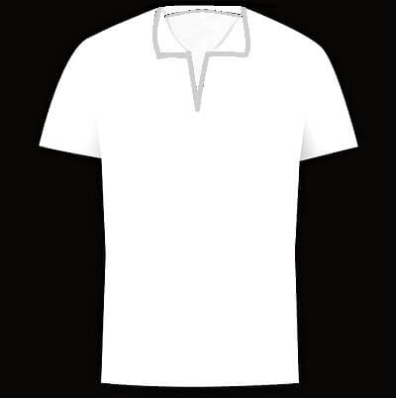
- 4 V-neck t-shirt
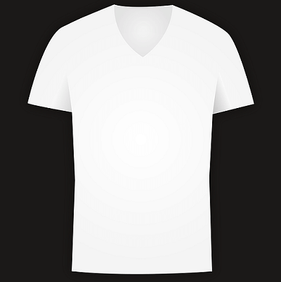
- 5 Wide neck –Off shoulder t-shirts (Girls’)
The wide neckline of this t-shirt makes it look like an off-shoulder top.
- 6 Yoke neck t-shirts (Girls’)
- T-shirts with a separate yoke. Usually, there will be embroidery on the yoke portion.
- 7 Boyfriend t-shirts (Girls’)
- Very loose t-shirts as opposed to body fitting t-shirts worn by women.
- 8 Douche bag neck t-shirt (Scoop neck)
- Men’s T-shirt which has a deep scoop neckline showing more of the body than a basic t-shirt would. It could be accompanied by metal chains and shaved chest to complete
- 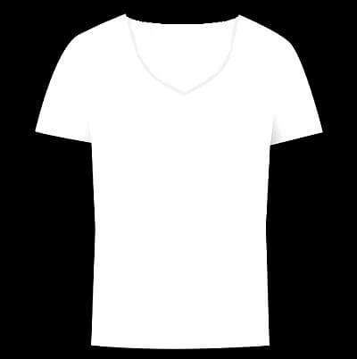

- 9 Henley collar T-shirt

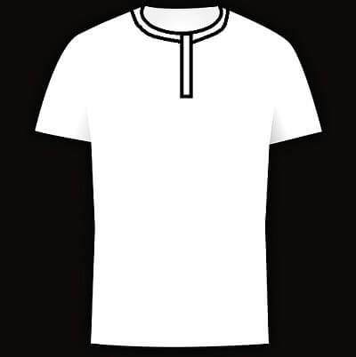
This Tshirt has a Placket below a round neckl
- 10 Baseball Tshirt

- 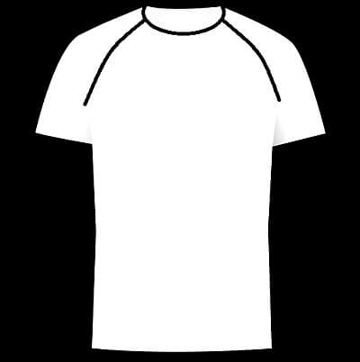

- 11 Raglan sleeve t-shirt – Long sleeve

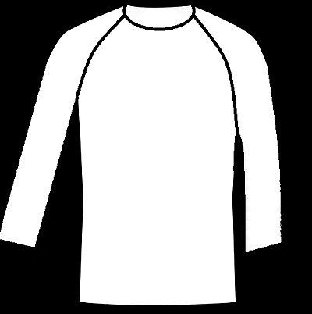

- 12 Turtle neck shirt

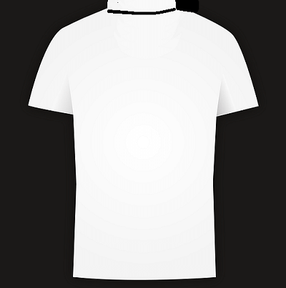

- 13 Ringer T – shirt

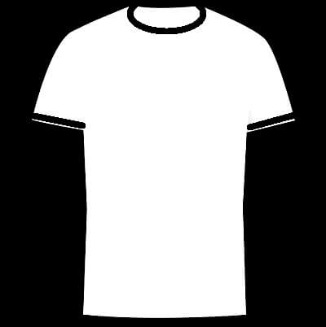

This is a crew necked T-shirt with contrast bands on the neckline and sleeve hems.

- 14 Cap sleeve t-shirt

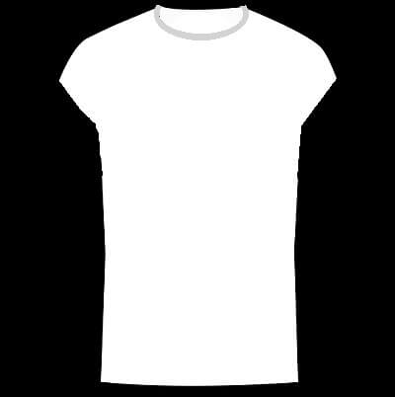
A t-shirt with a cap sleeve.

- 15 Half Tshirt (Singlet)

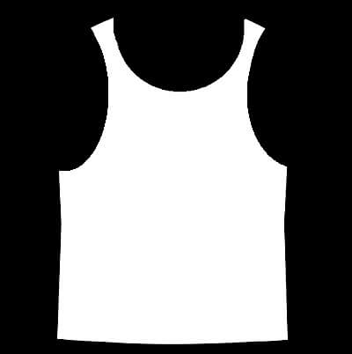

This is a sleeveless Tshirt with narrow straps – usually used by runners. As opposed to the muscle t-shirt mentioned below, this is a loose fitting comfortable sleeveless t-shirt
- 16 Muscle Shirt
- 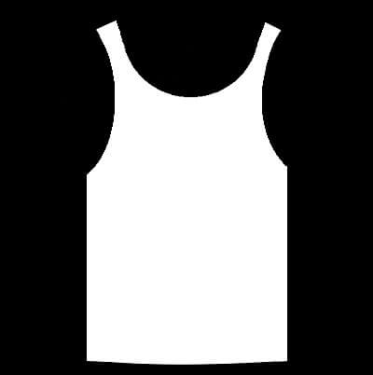

- 17 Half Muscle Shirt

Short length Muscle shirts with the hem ending above the belly button (to show off muscles on the stomach)

- 18 Longline T-shirt

The style of t-shirts with long length, even reaching up to the knees. Longline length, if done right can result in a look of slimmer elongated torso.

- 19 Pocket T-shirt

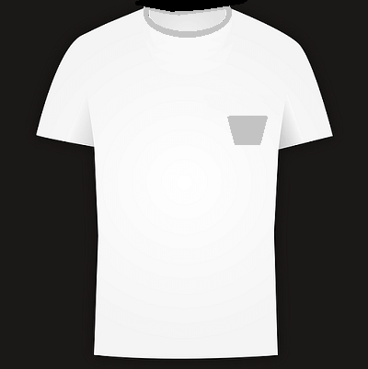
A T-shirt with a small pocket – functional or C

- 20 Baby Doll T-shirt
- This is a short and tight fitting t-shirt (with short or long sleeves)

Combining two or more fabrics allows the best qualities to emerge making the best T-shirts that feel great and last forever. The most popular is a cotton and polyester blend. The cotton remains cool and light while the polyester makes the shirt strong and wrinkle-resistant.

